What Is the UPI Transaction Limit per Day & Month? Complete Guide
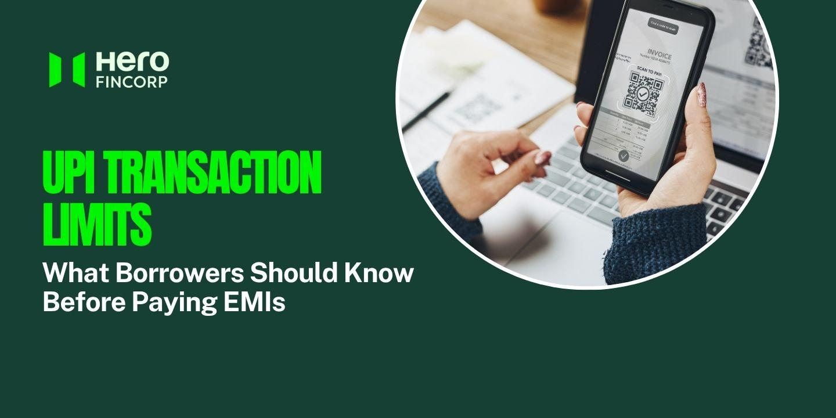
Image Source
Paying an EMI over UPI feels like second nature until the app refuses it. No warning, no explanation, just a decline on the evening the instalment is due. Almost always the cause is a limit nobody told you about. Here is what NPCI allows in a day, what changes once the payment gets large, and how to lift your own ceiling.
To Avail Personal Loan Apply Now

What Is the UPI Transaction Limit per Day?
The UPI transaction limit per day is Rs 1 lakh for most people, counted across every UPI app linked to the same bank account. That ceiling comes from NPCI. Banks are free to sit below it, and plenty do, holding basic or new accounts at Rs 25,000 a day. Two people in the same queue with the same app can have very different room to pay. No monthly cap exists at the NPCI level at all. Verified merchant categories run on far higher limits, and loan EMIs are one of them, reaching Rs 5 lakh in a single payment.

How the Caps Actually Work
There's a count as well as an amount. Twenty transactions a day, however small each one is, which catches people who pay for everything by phone long before the rupee limit does. UPI 123Pay stops at Rs 10,000 a payment. Collect requests, where the merchant pulls money rather than you pushing it, stop at Rs 2,000.
The daily window usually rolls rather than resetting at midnight, so hitting your cap at 11 am on Tuesday leaves you clear again at 11 am on Wednesday rather than at the stroke of twelve. Some banks do run a calendar-day reset instead. The limit screen inside your app is the only place that tells you which rule yours follows.

Higher Limits for Specific Payments
Since 15 September 2025, under an NPCI circular issued on 28 August that year, verified merchants in certain categories can accept much larger UPI payments.
Category | Per transaction | Per 24 hours
Loan EMIs and other collections | Rs 5 lakh | Rs 10 lakh
Insurance, capital markets, travel, Government e-Marketplace | Rs 5 lakh | Rs 10 lakh
Credit card bill payments | Rs 5 lakh | Rs 6 lakh
Jewellery | Rs 2 lakh | Rs 6 lakh
Hospitals and educational institutions | Rs 5 lakh | As per bank

Person-to-person transfers were left alone at Rs 1 lakh, so sending more than that to a friend still means leaving UPI altogether. IMPS carries up to Rs 5 lakh in one transfer and RTGS has no upper limit, though RTGS needs the recipient's account number and IFSC rather than a UPI ID.

What New Users Should Expect
For the first 24 hours after you set or reset a UPI PIN, the cap is Rs 5,000 across every app you use, and no bank can waive it. That rule exists because a stolen phone is most dangerous in the hour after the PIN changes. Standard limits apply once that window closes, although some banks keep newly opened accounts on a reduced daily cap for a month or so while the transaction history builds.

How to Check or Raise Your UPI Limit
Open your UPI app, go to Profile, then Bank Account, then Check Limit. The screen shows what you have left today alongside the daily total and the per-transaction cap your bank applies.
If the bank has capped you below Rs 1 lakh, customer care or a branch can usually lift it once your KYC is complete. Nobody takes you past NPCI's ceiling, whatever they promise. One 2026 change is worth knowing about. Since 7 August, under NPCI circular OC-226A, a fingerprint or a face scan can approve payments of up to Rs 10,000, double the earlier Rs 5,000. That changes how you authorise a payment rather than how much you can send, and none of the caps above moved.

Conclusion
Daily is the number that matters. Standard UPI transfers are capped at Rs 1 lakh a day and no separate monthly limit of UPI sits on top, so a month's room is simply your bank's daily cap multiplied out. Check the screen before a large EMI, not after it bounces. If the loan is with Hero FinCorp, Autopay takes the guesswork out of the date entirely.

Frequently Asked Questions

What Is the Monthly Limit of UPI?
There's no published one. NPCI's caps run per transaction and per 24 hours, so a month's ceiling is just your daily cap multiplied out, which comes to Rs 30 lakh on a Rs 1 lakh account. Some banks do add monthly ceilings of their own for newer accounts.

Is the UPI Transaction Limit the Same Across All Banks?
No. Rs 1 lakh is a ceiling rather than a standard, and every bank sets its own cap underneath it according to account type and risk profile. Nobody publishes these figures in one place, so the limit screen in your app is the only reading worth trusting.

How Can I Increase My UPI Limit?
Check the limit screen first, because some banks let you raise a self-imposed cap on the spot. Where the bank itself has capped you, customer care or your branch can move it. For anything above Rs 1 lakh you need a different rail, which means IMPS or RTGS.

What Happens if I Try to Send More Than My Daily UPI Limit?
Nothing leaves your account. The app simply declines the payment. Wait for the window to roll over, or move the balance across IMPS or NEFT instead. Your lender still records a declined EMI as a missed payment, so leaving it to the last evening is a bad habit.

Are UPI Limits Different for New Users Versus Existing Users?
Yes. Setting or resetting a UPI PIN brings a Rs 5,000 cap for the first 24 hours across all apps, and banks cannot waive it. Some then hold new accounts on a lower daily limit for roughly the first month.

